Part 4 – Mini System Design
1. High-level architecture
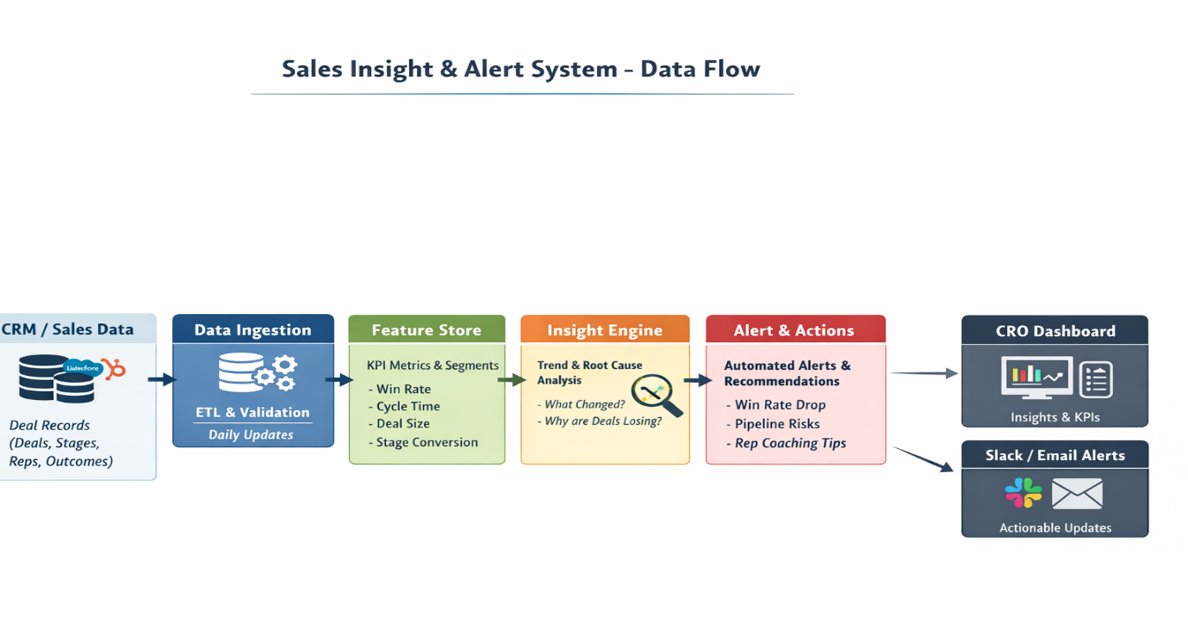
Fig 1 – Block Diagram

2. Data Flow
Step 1 — Data Ingestion
Pull deal-level fields:
- deal_id
- created_date / closed_date
- industry, region, product_type
- deal_stage
- deal_amount
- lead_source
- sales_rep_id
- outcome (Won/Lost)

Step 2 — Metric Computation
Compute rolling KPIs:
- Win rate (overall + segmented)
- Avg sales cycle days
- Deal size trends
- Stage conversion rates
- Rep-level performance shifts
Example derived features:
- cycle_bucket = short/medium/long
- high_value_flag = ACV > 75th percentile
- stage_drop_off_rate

3. Example Alerts & Insights
Alert 1 — Win Rate Drop
Trigger:
Win rate drops > 8% compared to last quarter
Message:
Win rate declined from 31% → 22% in the last 60 days.
Suggested Action:
Focus on pipeline quality + late-stage execution.

Alert 2 — Region-Specific Risk
Trigger:
One region loses significantly more
Insight Example:
APAC win rate dropped 18%, while North America stayed flat.
Action:
Investigate competitive pressure or rep coverage in APAC.

Alert 3 — Lead Source Decay
Trigger:
Outbound deals losing more than usual
Outbound win rate fell from 25% → 12% in Q2.
Action:
Re-evaluate targeting or messaging for outbound campaigns.

Alert 4 — Rep Coaching Opportunity
Trigger:
Rep performance shifts sharply
Rep_5 win rate dropped 40% in Enterprise deals.
Action:
Enable deal reviews + negotiation support.

Alert 5 — Deal Cycle Expansion
Trigger:
Sales cycle increasing
Average cycle increased from 32 → 51 days.
Action:
Deals are stalling → improve follow-up + qualification.

Alert 6 — Stage Bottleneck
Trigger:
Proposal-to-close conversion drops
Proposal stage loss rate increased by 22%.
Action:
Improve pricing clarity, competitive enablement, objection handling.

CRO Insight Digest
- Win rate trend: ↓ 9%
- Biggest loss driver: Enterprise + Outbound
- Stage breakdown: Proposal stage drop-off
- Region risk: APAC losses rising
- Top rep needing support: rep_18
- Recommended focus this week:
  - Fix outbound targeting
  - Coach proposal-stage execution
  - Review APAC pipeline quality

4. How Often It Runs
Component | Frequency
Data ingestion | Daily
KPI + trend computation | Daily
Alerts | Real-time or Daily
CRO summary report | Weekly
Deep RCA analysis | Monthly

5. Failure Cases & Limitations
Data Issues
- Missing closed dates → inaccurate cycle metrics
- Incorrect stage labeling → funnel breakdown unreliable
Small Sample Bias
- Segment insights may be noisy if deal volume is low
Correlation ≠ Causation
- System identifies patterns, not guaranteed causes
No Activity-Level Context
Dataset lacks:
- Calls
- Emails
- Meeting count
- Product usage
Future improvement: integrate activity + product signals.

